TUGAS INDIVIDU
Basis Data NoSQL

DOSEN: M. Harry Khomas Saputra S.T., M.TI.
ARYA TIRTA (225443005)



1AEC-1
TEKNOLOGI REKAYASA INFORMATIKA INDUSTRI
POLITEKNIK MANUFAKTUR BANDUNG
TAHUN AJARAN 2025/2026

Desain Data

Diagram Koleksi sensor

Field | Tipe Data | Contoh Nilai | Keterangan
mesin | String | CNC-01 | ID mesin
suhu | Float | 85.5 | Suhu mesin (°C)
getaran | Float | 0.32 | Tingkat getaran
timestamp | Date | 2026-05-06T08:20:00 | Waktu pencatatan data
status | String | normal / maintenance | Status kondisi mesin

Diagram Koleksi maintenance

Field | Tipe Data | Contoh Nilai | Keterangan
mesin | String | CNC-01 | ID mesin
tanggal | Date | 2024-01-10 | Tanggal maintenance
biaya | Integer | 1200000 | Biaya perawatan
teknisi | String | Andi | Nama teknisi

- FASE 1 : Setup Lingkungan
  - Membuat file . env
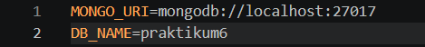

  - Membuat file koneksi.py
- import os
- from dotenv import load_dotenv
- from pymongo import MongoClient

- load_dotenv()
- client = MongoClient(os.getenv("MONGO_URI"), serverSelectionTimeoutMS=5000)

- try:
- client.admin.command('ping')
- print("Koneksi MongoDB berhasil!")
- except Exception as e:
- print("Gagal terhubung:", e)
- finally:
- client.close()

- FASE 2 : Operasi Dasar CRUD
  - Membuat file crud_sensor.py
from dotenv import load_dotenv
from pymongo import MongoClient
from datetime import datetime, timedelta
import random, os

load_dotenv()
client = MongoClient(os.getenv("MONGO_URI"))
db = client[os.getenv("DB_NAME")]
collection = db["sensor"]

  - Membuat file insert_many.py
from dotenv import load_dotenv
from pymongo import MongoClient
from datetime import datetime, timedelta
import random, os

load_dotenv()
client = MongoClient(os.getenv("MONGO_URI"))
db = client[os.getenv("DB_NAME")]
collection = db["sensor"]

data = []
for i in range(10):
doc = {
"mesin": f"CNC-{random.randint(1,3):02d}",
"suhu": round(random.uniform(60, 100), 2),
"getaran": round(random.uniform(0.1, 0.5), 2),
"timestamp": datetime.utcnow() - timedelta(minutes=i*5),
"status": "normal"
}
data.append(doc)
result = collection.insert_many(data)
print(f"Tersimpan {len(result.inserted_ids)} dokumen")
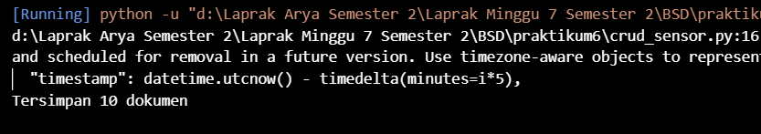

  - Membuat file read.py
from dotenv import load_dotenv
from pymongo import MongoClient
from datetime import datetime, timedelta
import random, os

load_dotenv()
client = MongoClient(os.getenv("MONGO_URI"))
db = client[os.getenv("DB_NAME")]
collection = db["sensor"]

cursor = collection.find(
{"mesin": "CNC-01"},
{"_id": 0, "suhu": 1, "timestamp": 1}
).sort("timestamp", -1).limit(5)
print("Data CNC-01 terbaru:")
for doc in cursor:
print(doc)
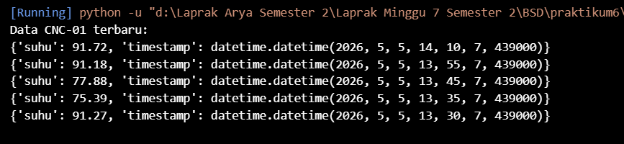

  - Membuat file update.py
from dotenv import load_dotenv
from pymongo import MongoClient
from datetime import datetime, timedelta
import random, os

load_dotenv()
client = MongoClient(os.getenv("MONGO_URI"))
db = client[os.getenv("DB_NAME")]
collection = db["sensor"]

update_result = collection.update_many(
{"suhu": {"$gt": 90}},
{"$set": {"status": "maintenance"}}
)
print(f"Update: {update_result.modified_count} dokumen diubah")
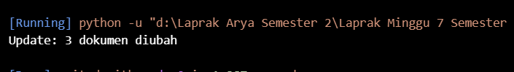

  - Membuat delete.py
from dotenv import load_dotenv
from pymongo import MongoClient
from datetime import datetime, timedelta
import random, os

load_dotenv()
client = MongoClient(os.getenv("MONGO_URI"))
db = client[os.getenv("DB_NAME")]
collection = db["sensor"]

satu_jam_lalu = datetime.utcnow() - timedelta(hours=1)
delete_result = collection.delete_many({"timestamp": {"$lt": satu_jam_lalu}})
print(f"Delete: {delete_result.deleted_count} dokumen dihapus")
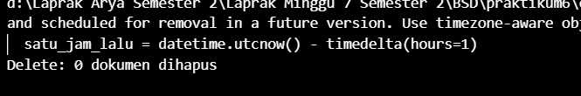

- FASE 3 : Agregasi via Python
  - Membuat file agregasi.py
import os
from dotenv import load_dotenv
from pymongo import MongoClient

load_dotenv()
client = MongoClient(os.getenv("MONGO_URI"))
db = client[os.getenv("DB_NAME")]
collection = db["sensor"]

pipeline = [
{"$group": {
"_id": "$mesin",
"rata_suhu": {"$avg": "$suhu"},
"max_getaran": {"$max": "$getaran"},
"count": {"$sum": 1}
}},
{"$sort": {"rata_suhu": -1}}
]

results = collection.aggregate(pipeline)
print("Rata-rata suhu per mesin:")
for doc in results:
print(f"{doc['_id']} -> rata:{doc['rata_suhu']:.2f}°C, max getaran:{doc['max_getaran']}, jumlah data:{doc['count']}")

client.close()
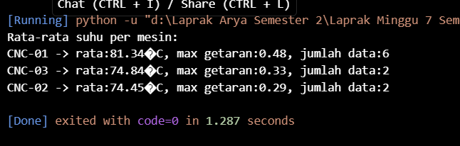

- FASE 4 : Analisis dengan pandas
  - Membuat file analisis.py
import os
import pandas as pd
import matplotlib.pyplot as plt
from dotenv import load_dotenv
from pymongo import MongoClient

load_dotenv()
client = MongoClient(os.getenv("MONGO_URI"))
db = client[os.getenv("DB_NAME")]
collection = db["sensor"]

cursor = collection.find({}, {"_id": 0})
df = pd.DataFrame(list(cursor))

df['timestamp'] = pd.to_datetime(df['timestamp'])
df.set_index('timestamp', inplace=True)

resampled = df.resample('10min').mean(numeric_only=True)
print(resampled.head())

plt.figure(figsize=(10,5))
df['suhu'].plot(title='Suhu dari Waktu ke Waktu')
plt.ylabel('Suhu (°C)')
plt.grid(True)
plt.savefig('suhu_plot.png')
plt.show()

client.close()
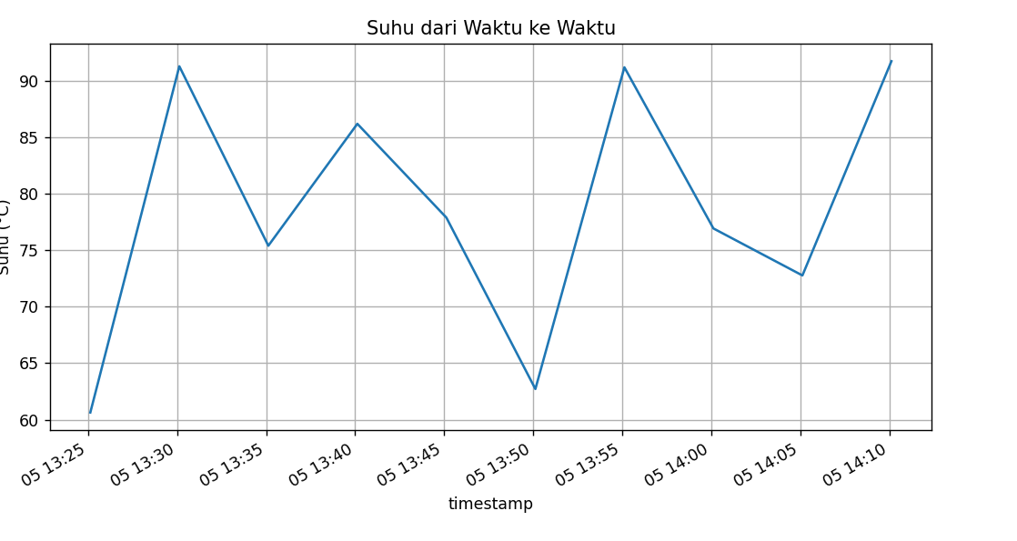

- FASE 5 : Data Generator Langsung
  - Membuat file data_generator.py
import time, random
from datetime import datetime
from pymongo import MongoClient
import os
from dotenv import load_dotenv

load_dotenv()
client = MongoClient(os.getenv("MONGO_URI"))
db = client[os.getenv("DB_NAME")]
collection = db["sensor"]

while True:
doc = {
"mesin": f"CNC-{random.randint(1,5):02d}",
"suhu": round(random.uniform(60, 100), 2),
"getaran": round(random.uniform(0.1, 0.5), 2),
"timestamp": datetime.utcnow()
}
collection.insert_one(doc)
print(f"[{datetime.utcnow()}] Inserted: {doc['mesin']} - {doc['suhu']}°C")
time.sleep(2)
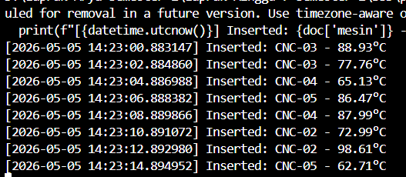

- FASE 5B (lanjutan) :
  - Membuat file mqtt_publisher.py
import json, time, random
import paho.mqtt.client as mqtt
from datetime import datetime

BROKER = "test.mosquitto.org"
PORT = 1883
TOPIC = "pabrik/sensor/suhu"

client = mqtt.Client(mqtt.CallbackAPIVersion.VERSION2)
client.connect(BROKER, PORT, 60)

while True:
data = {
"mesin": f"CNC-{random.randint(1,5):02d}",
"suhu": round(random.uniform(60, 100), 2),
"getaran": round(random.uniform(0.1, 0.5), 2),
"timestamp": datetime.utcnow().isoformat()
}
payload = json.dumps(data)
client.publish(TOPIC, payload)
print(f"[PUB] {payload}")
time.sleep(2)

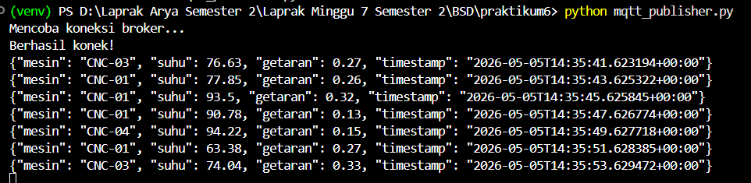

  - Membuat file mqtt_subscriber.py
import json, os
import paho.mqtt.client as mqtt
from pymongo import MongoClient
from datetime import datetime
from dotenv import load_dotenv

load_dotenv()
MONGO_URI = os.getenv("MONGO_URI")
DB_NAME = os.getenv("DB_NAME")

mongo_client = MongoClient(MONGO_URI)
db = mongo_client[DB_NAME]
collection = db["sensor"]

def on_connect(client, userdata, flags, rc, properties=None):
print("Terhubung ke MQTT broker")
client.subscribe("pabrik/sensor/suhu")

def on_message(client, userdata, msg):
try:
payload = json.loads(msg.payload.decode())

payload["timestamp"] = datetime.fromisoformat(payload["timestamp"])

result = collection.insert_one(payload)

print(
f"[MONGO] Tersimpan {result.inserted_id} - "
f"{payload['mesin']} {payload['suhu']} C"
)

except Exception as e:
print("Error:", e)

mqtt_client = mqtt.Client(mqtt.CallbackAPIVersion.VERSION2)

mqtt_client.on_connect = on_connect
mqtt_client.on_message = on_message

print("Mencoba koneksi ke broker...")
mqtt_client.connect("broker.hivemq.com", 1883, 60)

print("Menunggu data MQTT...")
mqtt_client.loop_forever()
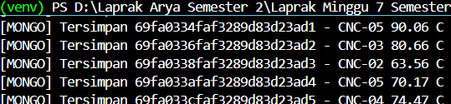

- FASE 6 : Error Handlling dan Logging
  - Contoh penambahan logging pada crud_sensor.py (di awal file), kemudian bungkus insert_many dengan try-except:
from dotenv import load_dotenv
from pymongo import MongoClient
from datetime import datetime, timedelta
import random, os

load_dotenv()
client = MongoClient(os.getenv("MONGO_URI"))
db = client[os.getenv("DB_NAME")]
collection = db["sensor"]
data = []
for i in range(10):
doc = {
"mesin": f"CNC-{random.randint(1,3):02d}",
"suhu": round(random.uniform(60, 100), 2),
"getaran": round(random.uniform(0.1, 0.5), 2),
"timestamp": datetime.utcnow() - timedelta(minutes=i*5),
"status": "normal"
}
data.append(doc)
result = collection.insert_many(data)
print(f"Tersimpan {len(result.inserted_ids)} dokumen")

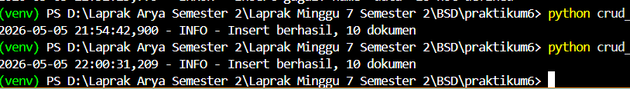

Latihan Mandiri
- Buat file csv lalu isi dengan ini:
mesin,tanggal,biaya,teknisi
CNC-01,2026-05-01,1200000,Andi
CNC-02,2026-05-03,900000,Budi
CNC-03,2026-05-10,1500000,Citra
CNC-01,2026-06-02,800000,Andi
CNC-04,2026-06-05,2000000,Eko

Setelah itu, save terlebih dahulu
Buat file import_maintenance.py dan isi dengan kode berikut:
import pandas as pd
import os
from pymongo import MongoClient
from dotenv import load_dotenv

load_dotenv()

client = MongoClient(os.getenv("MONGO_URI"))
db = client[os.getenv("DB_NAME")]
collection = db["maintenance"]

df = pd.read_csv("maintenance.csv")

df["tanggal"] = pd.to_datetime(df["tanggal"])

data = df.to_dict("records")

result = collection.insert_many(data)

print("Data berhasil diimport")
print("Jumlah data:", len(result.inserted_ids))
Output:

- Buat file query_maintenance.py lalu isi dengan kode berikut:
import os
import pandas as pd
from pymongo import MongoClient
from dotenv import load_dotenv

load_dotenv()

client = MongoClient(os.getenv("MONGO_URI"))
db = client[os.getenv("DB_NAME")]
collection = db["maintenance"]

print("\n=== Data biaya > 1.000.000 ===")

hasil = list(collection.find(
{"biaya": {"$gt": 1000000}},
{"_id": 0}
))

df = pd.DataFrame(hasil)
print(df)

print("\n=== Update Teknisi ===")

update_result = collection.update_many(
{
" mesin": "CNC-01",
"biaya": 1200000
},
{
"$set": {
"teknisi": "Dewi"
}
}
)

print("matched:", update_result.matched_count)
print("modified:", update_result.modified_count)

print("matched:", update_result.matched_count)
print("modified:", update_result.modified_count)

print("\n=== Total biaya per bulan ===")

pipeline = [
{
"$group": {
"_id": {
"$dateToString": {
"format": "%Y-%m",
"date": "$tanggal"
}
},
"total_biaya": {
"$sum": "$biaya"
}
}
},
{
"$sort": {
"_id": 1
}
}
]

result = list(collection.aggregate(pipeline))

df_agregasi = pd.DataFrame(result)
print(df_agregasi)

client.close()
Output:
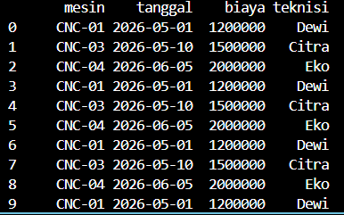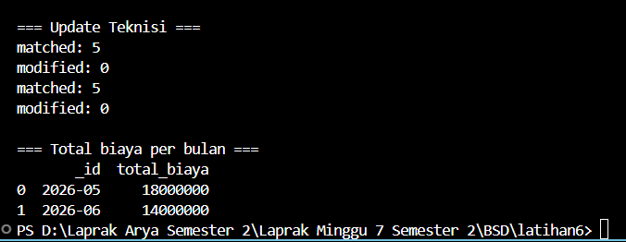

LATIHAN MANDIRI 2(Opsional)

MQTT Publisher
import paho.mqtt.client as mqtt
import json
import time
import random

broker = "broker.hivemq.com"
topic = "pabrik/produksi"

client = mqtt.Client()
client.connect(broker, 1883, 60)

mesin_list = ["CNC-01", "CNC-02", "CNC-03", "CNC-04"]
batch_list = ["B001", "B002", "B003", "B004"]

while True:
data = {
"batch": random.choice(batch_list),
"mesin": random.choice(mesin_list),
"jumlah": random.randint(100, 500),
"reject": random.randint(0, 50)
}

client.publish(topic, json.dumps(data))
print("Kirim:", data)

time.sleep(3)

Output
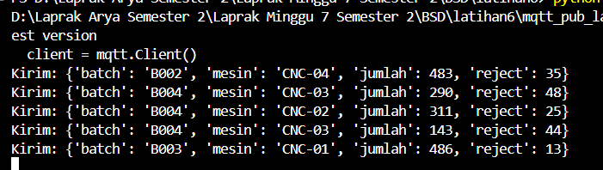

MQTT Subscirber
import paho.mqtt.client as mqtt
import json
from pymongo import MongoClient
from datetime import datetime

mongo_client = MongoClient("mongodb://localhost:27017")
db = mongo_client["latihan_mqtt"]
collection = db["produksi_mqtt"]

broker = "broker.hivemq.com"
topic = "pabrik/produksi"

def on_connect(client, userdata, flags, rc):
print("Terhubung ke broker")
client.subscribe(topic)

def on_message(client, userdata, msg):
data = json.loads(msg.payload.decode())

data["timestamp"] = datetime.now()

reject_rate = (data["reject"] / data["jumlah"]) * 100
data["reject_rate"] = reject_rate

if reject_rate > 5:
print("⚠️ PERINGATAN! Reject rate terdeteksi tinggi:", reject_rate)
data["peringatan"] = True
else:
data["peringatan"] = False

collection.insert_one(data)

print("Data masuk:", data)

client = mqtt.Client()
client.on_connect = on_connect
client.on_message = on_message

client.connect(broker, 1883, 60)
client.loop_forever()

Output
